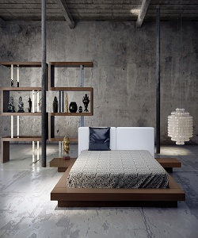

Lexington bed

$252.95

Availability: In stock

Description

Modern loft-style light wood floor bed. Wood frame made with finish, it has two arm that will work like side table. This Lexington bed collection’s great bed will make your room center of attraction, décor your room with our new collection. With two years’ grantee. Assembly required.